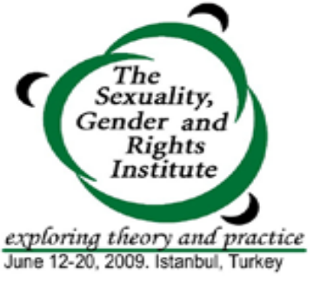
APPLICATION FORM
Istanbul, Turkey
June 12-20, 2009

The Sexuality, Gender and Rights Institute is a week long residential course that focuses on a conceptual study of sexuality and examines the links between sexuality, rights, gender and health. The Institute is organized by CREA. Individuals who work on sexuality, rights, gender or health are eligible to apply.

Deadline to apply: April 18, 2009 (on or before)

Guidelines: You can send the completed application form through email to sluthra@creaworld.org. Attach a copy of your latest resume or CV. All questions must be answered — your resume or CV cannot substitute for an answer.

Name:
 | Contact Information
Address:
Telephone: |  |  |  | Fax:
Cell Number: |  |  |  | Email:
 | Professional Background
Profession:
Current Position:
Organization/Institution:
Address:
Telephone: |  |  | Fax:
Email:
 | Educational Background
Year | Institution | Subjects |  |  |  | Degree

1. Please list any previous courses related to sexuality, reproductive health, gender or rights that you have attended.

2. How did you hear about this program? (in not more than 50 words)

3. Describe your professional interests, your work, and any issues that you have worked on that relate to sexuality and rights (in not more than 250 words).

4. Explain why you want to take this course and how you expect it to contribute to your professional development (in not more than 150 words).

5. Please give the names of two references, one other than your employer, who are knowledgeable about your work.
a) | Name:
 | Organization:
 | Telephone: |  |  | Email:
b) | Name:
 | Organization:
 | Telephone: |  | Email:

6. Fees:
- The total cost per participant for the course is USD 1600 (tuition is USD 750; boarding and lodging is USD 750; registration is USD 100). Please note that this a subsidized cost for participation. All selected participants must pay the registration fee and their own travel costs. Fees due by May 15, 2009.
- Participants are encouraged to secure their own funding. Possible sources include: the organization you work for, the funders for your organization, government development organizations, the United Nations and related agencies, and foundations such as the Global Fund for Women, Mama Cash, the Ford Foundation, and the Open Society Institute.
- A limited number of full and partial scholarships from CREA are available on a need basis. Priority will be given to individuals who are working on sexuality related issues.

Scholarship request (please tick):
Full scholarship [ ] USD 1500 (Does not include registration fee or travel costs.)
Tuition Scholarship [ ] USD 750
Lodging [ ] USD 550
Boarding [ ] USD 200
Partial scholarship [ ] Indicate amount requested (USD)______________

7. If you are requesting a scholarship, please explain why it is needed (100 words or less).

8. Accommodations will be in double rooms. Would you prefer to share with a participant of the same gender?

If yes, your gender is:

If there is any other information relevant to room sharing, please let us know.

9. Please provide any other information that you consider relevant (not exceeding 50 words).

Completed application forms are due on or before April 18, 2009. Applications received after this date will not be considered. Applicants will be notified of the Selection Committee’s decision by April 30.

Email applications and queries to: Sushma Luthra at sluthra@creaworld.org

If you need to mail your application, use one of these addresses: Or fax to:

CREA CREA 91 11 2437 7708
116 E. 16th St., 7th Floor 7 Mathura Rd. Jangpura B, 2nd Fl

New York, NY 10003, U.S.A. New Delhi – 10014, India

